

**DRAFT**

**BIM to GIS Standard**

Version Date: June 2019

1 BIM to GIS transfer package creation 1

1.1 **Floor plan Export:** 2

1.2 **Space Export** 15

1.3 **Door Export** 24

1.4 Transfer package 29

# BIM to GIS transfer package creation

The BIM to GIS transfer package is assembled from the outcomes of three processes:

1. **Floor Plan Export** - Export 2D floor plans from Revit in DWG format to be used as graphic backgrounds in GIS
2. **Space Export** - Export 3D Room elements (SFO Spaces) from Revit in IFC format
3. **Door Export** - Export the location and number of doors as tabular data in XLS (Excel 97-2003) format

Once assembled, transfer the package to the GIS using the correct protocol.

## **Floor plan Export:**

* 1. Open the Revit model by selecting the “Detach from Central”:  
     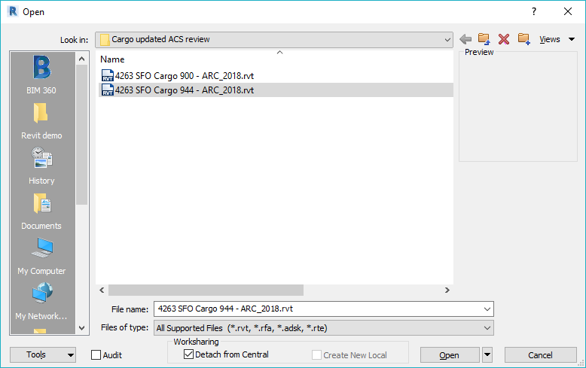
  2. Save a copy to avoid overwriting original: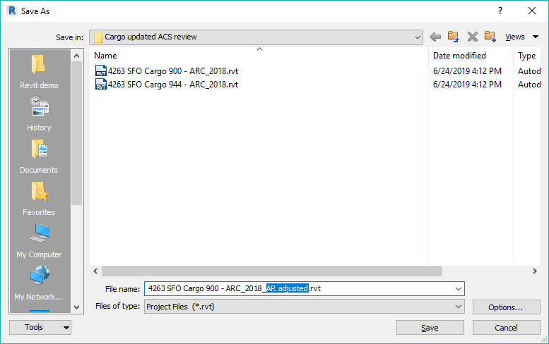
  3. Locate the floor plan which you want to export in the “Project Browser”:  
     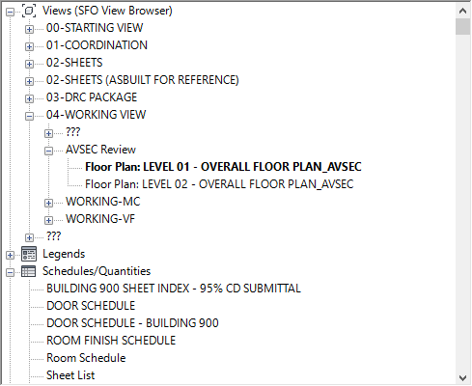
  4. Confirm coordinate system alignment by locating the SFO-B Origin Marker:  
     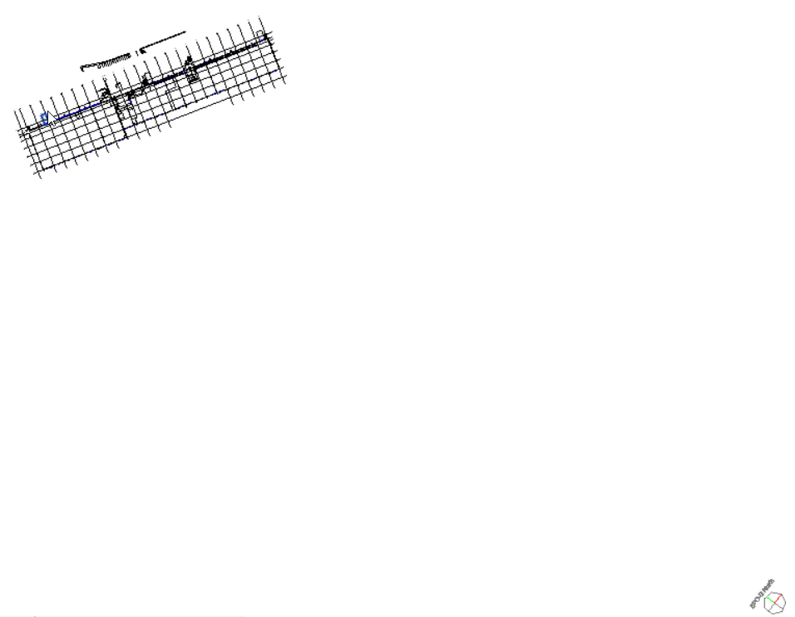
  5. Check floor plan view orientation:  
     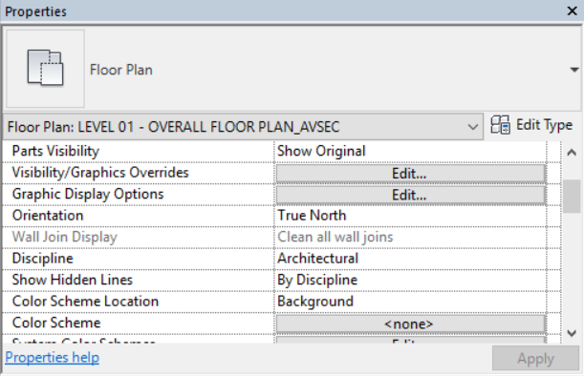
  6. Open Visibility Graphics window by typing VG on your keyboard. Turn on visibility of Project Base Point and Survey Point:  
     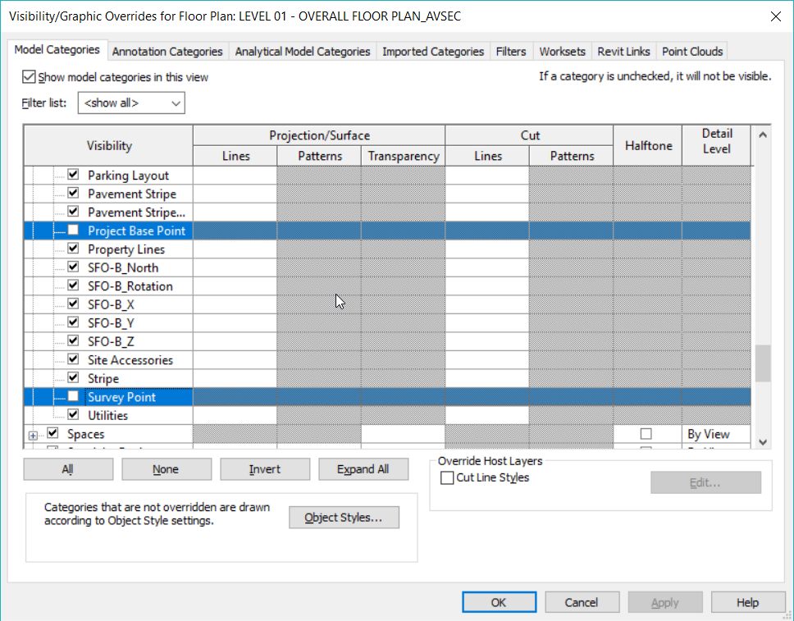
  7. Move the un-clipped Project Base Point to the SFO-B Origin Marker. Ensure you are snapping to the center.  
     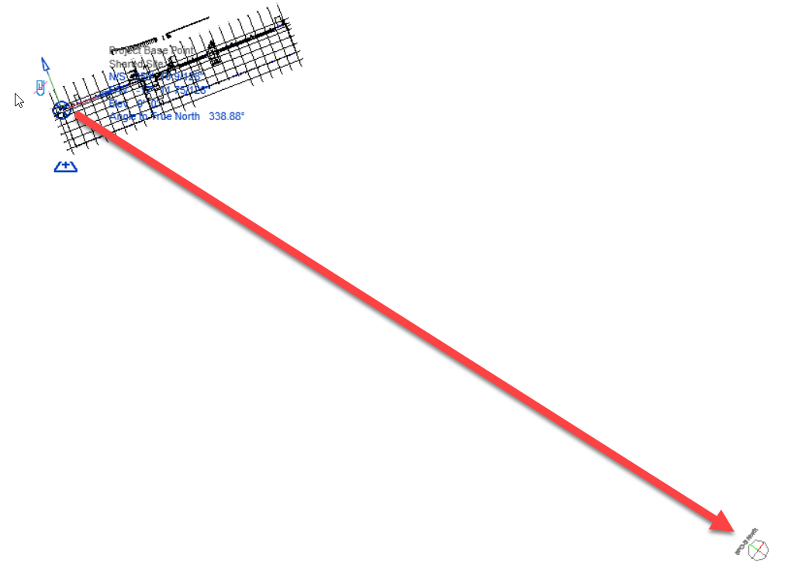
  8. Clip the Project Base Point and change its coordinates to 0,0:  
     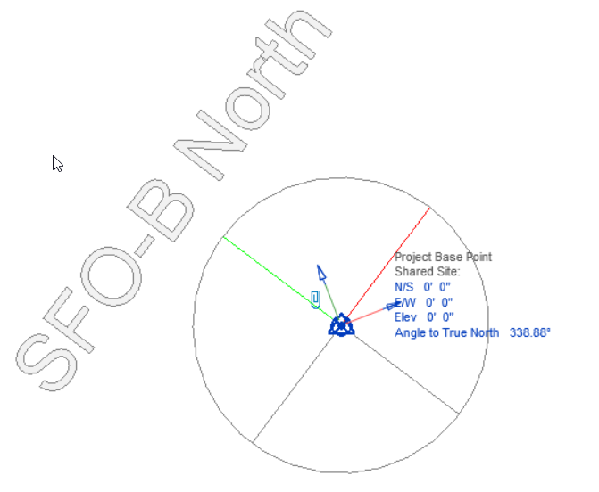
  9. Rotate True North to align with SFO-B: 1. Select SFO B marker

2. Find the ______ ribbon

3. Select position dropdown

4. Select rotate true North

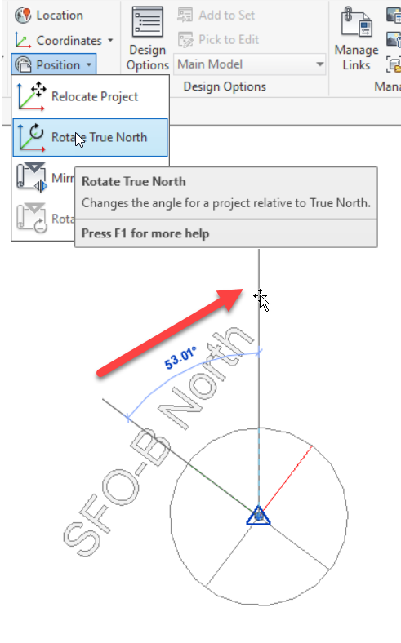

**1**

**3**

**4**

* 1. Export floor plan view in DWG format:  
     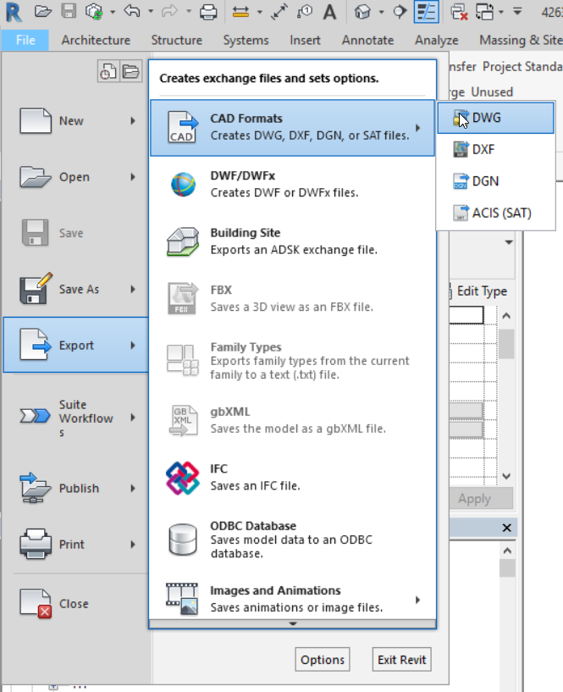

**2**

**1**

**3**

* 1. Select “Foot” as DWG unit and “Shared” as Coordinate System basis:  
     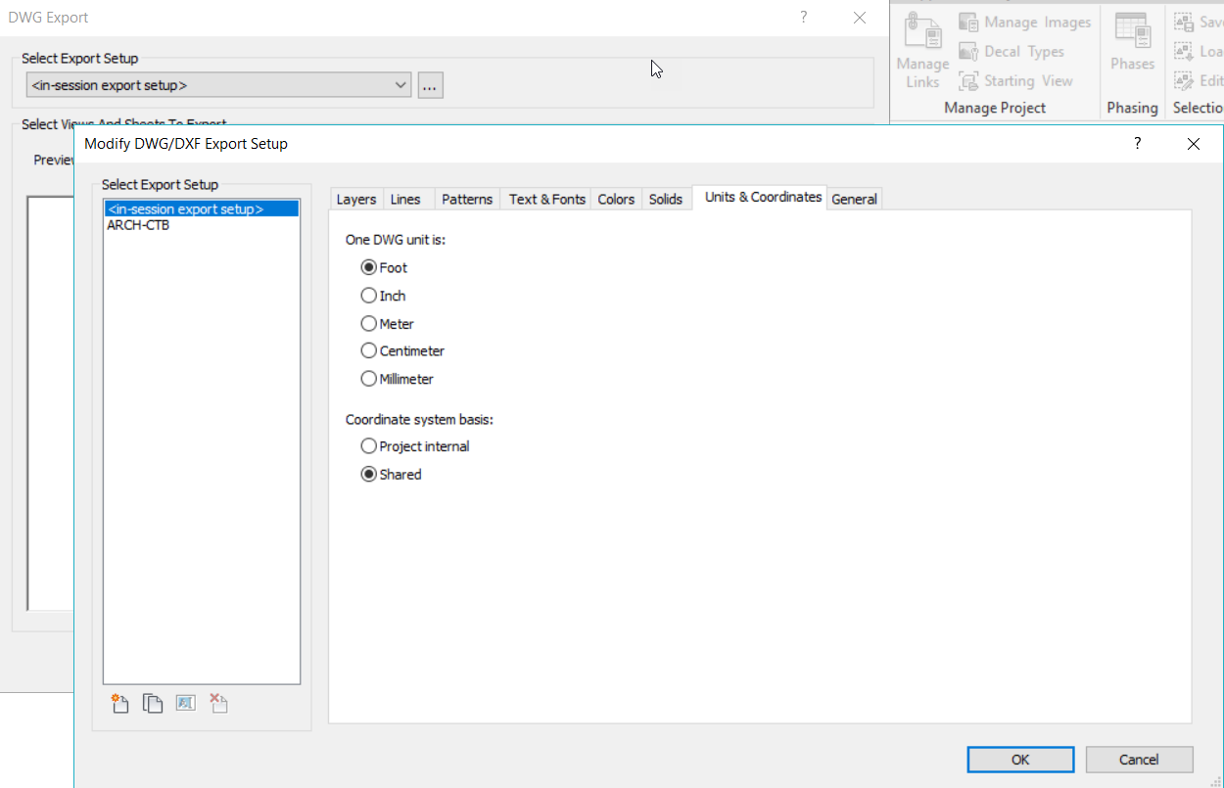
  2. Select AutoCAD DWG 2013 as the file format:  
     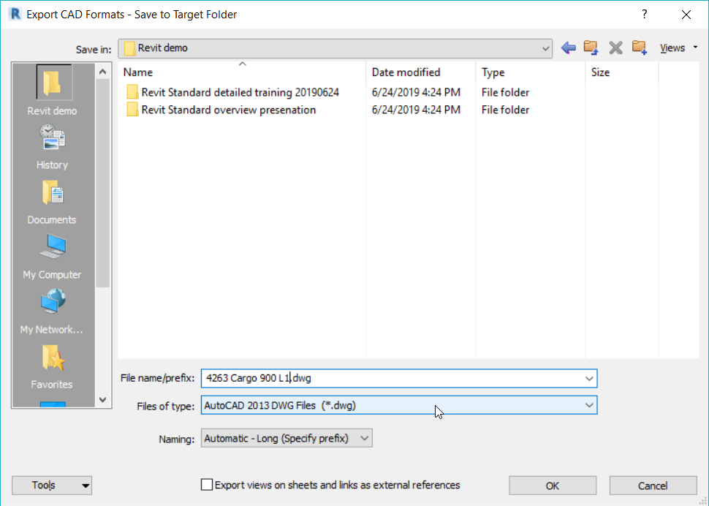
  3. Verify the Coordinate System alignment of the DWG by starting a line in AutoCAD at 0,0:  
     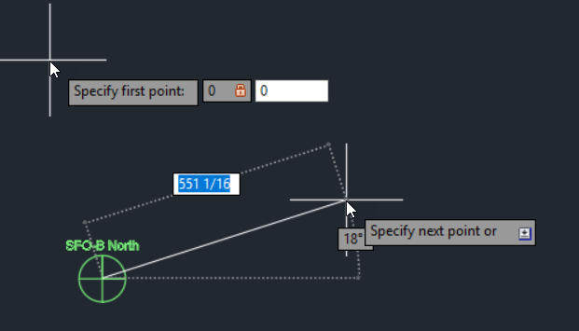

## **Space Export**

1. Visually verify floor plan space coverage by a dedicated view:

Note : Ask Charles for further steps on how this is done … or if this is detail is necessary.  
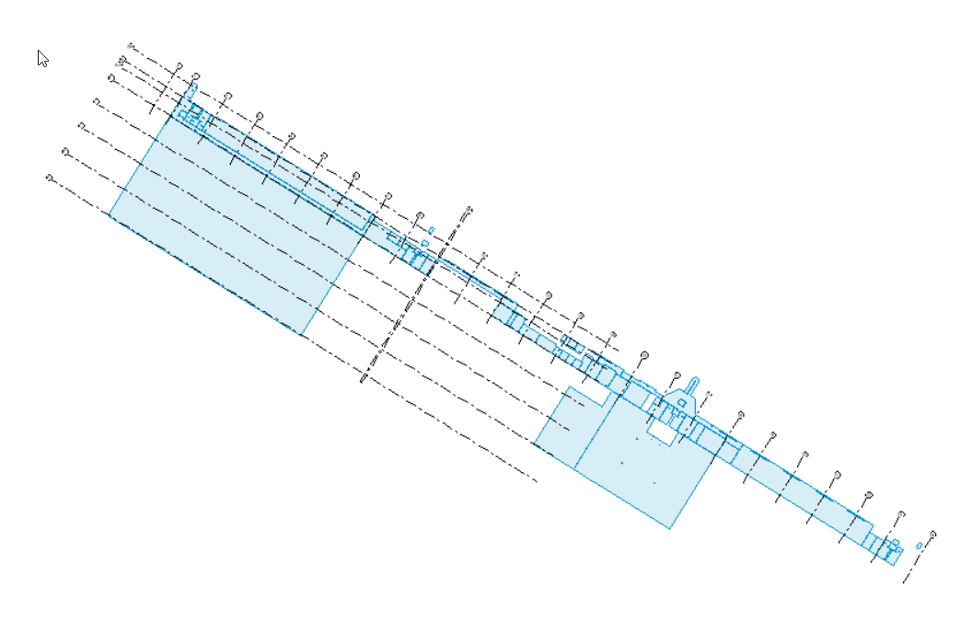

1. Export rooms objects (SFO Spaces) in IFC format:  
   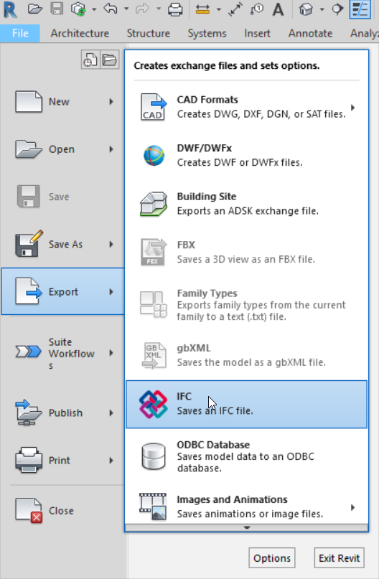

**1**

**2**

1. Browse to a desired location for file name:  
   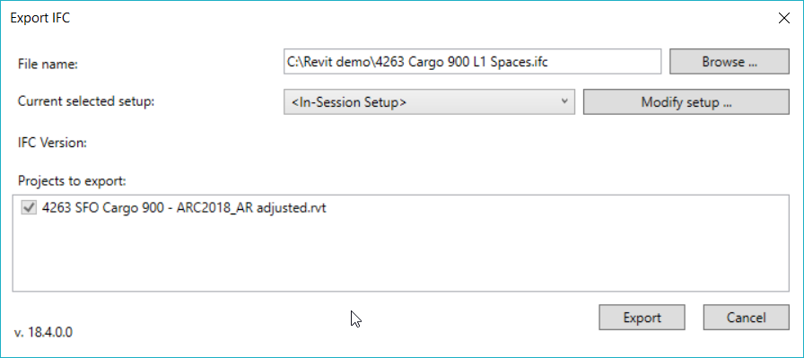
2. Under modify setup/ general, use IFC4 Reference View as IFC version, 1st Level as space boundaries, and current shared coordinates as Project Origin:  
   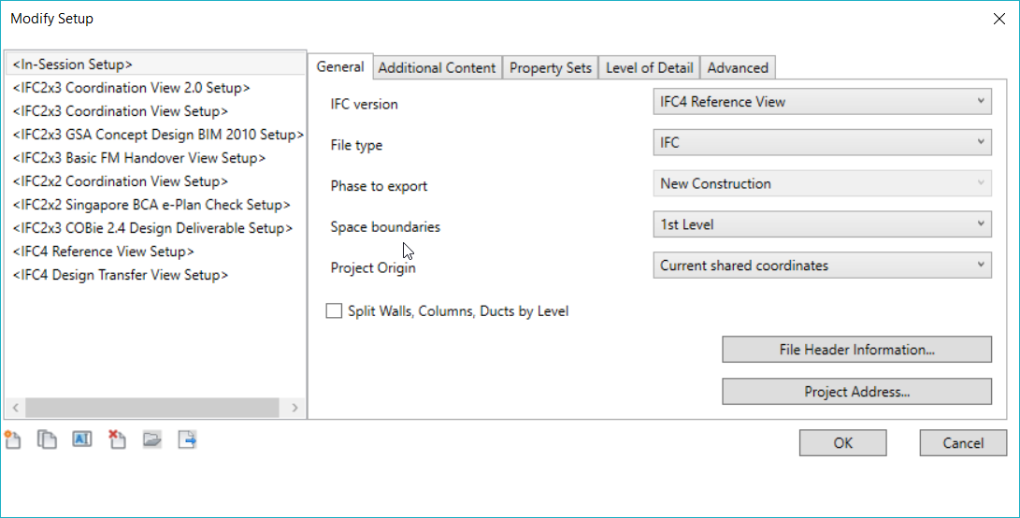
3. Select Export only elements in visible view and Export rooms in 3D views under Additional Content:  
   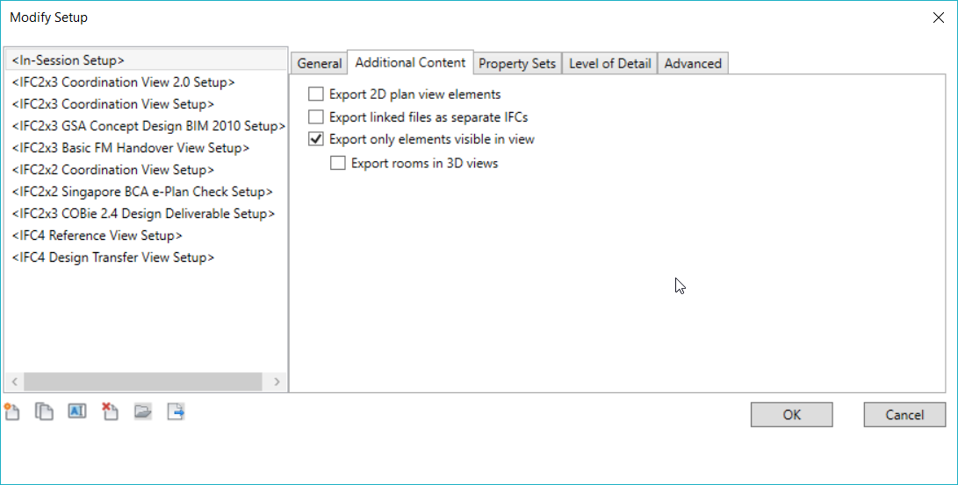
4. Select Use 2D room boundaries for room volume under Advanced:  
   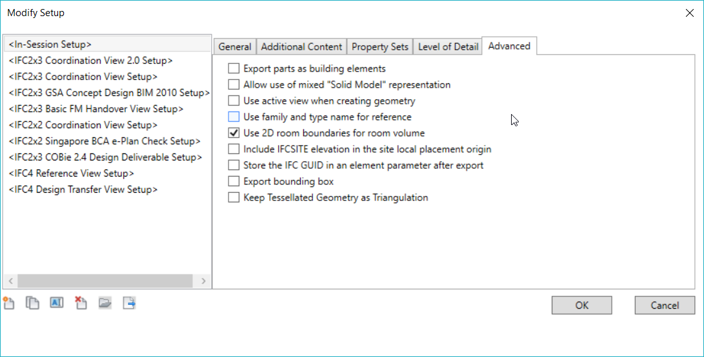
5. Verify the coordinate system alignment of the IFC model and the attributes of spaces in an IFC model viewer (e.g. Solibri or BIM Vision): 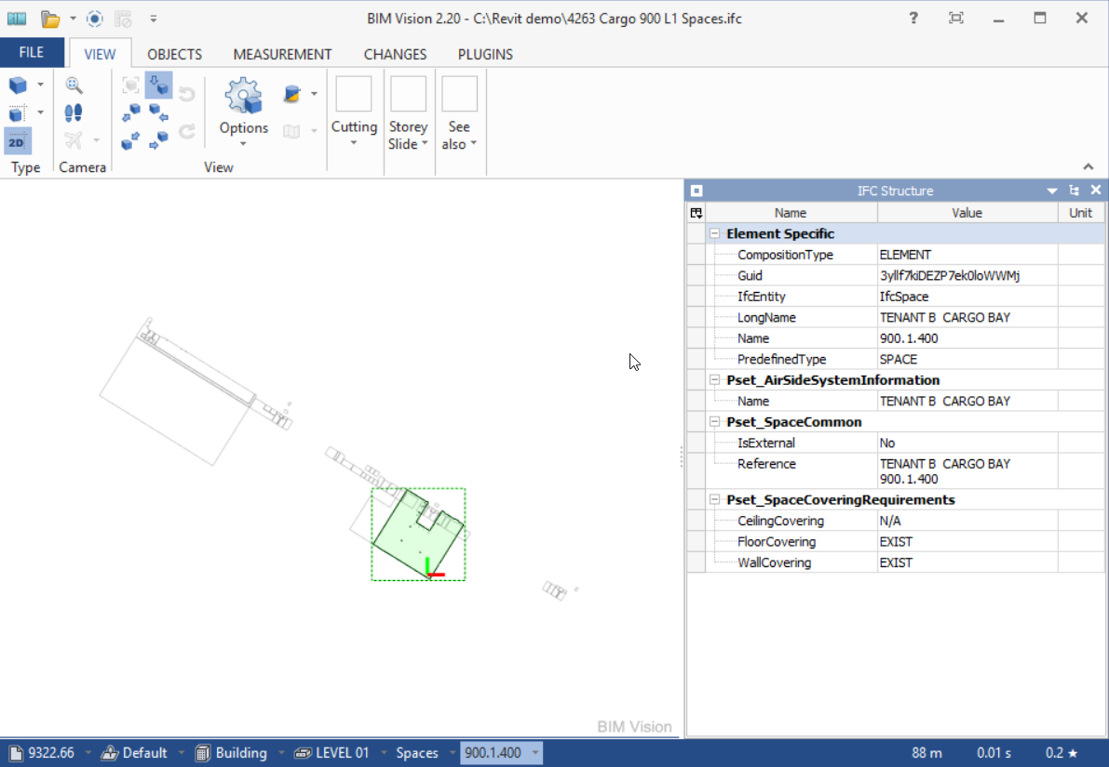

## **Door Export**

1. Identify or create a door schedule including the doors that you want to transfer:  
   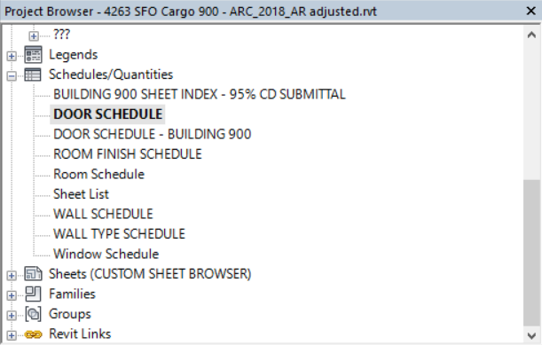
2. Confirm that it includes the door number field corresponding to numbering requirements:  
   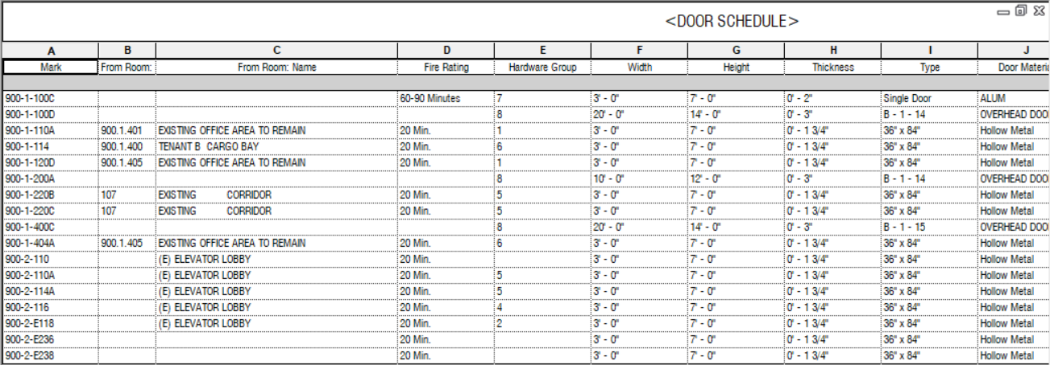
3. Create a Link in Ideate BIMLink from the Revit schedule:  
   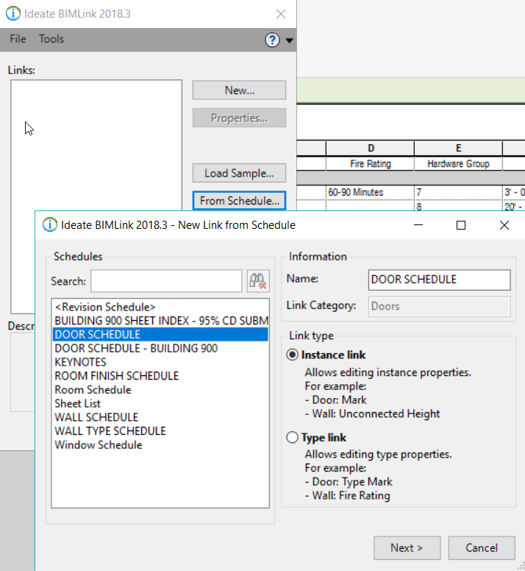
4. Add Coordinates: Point_X and Coordinates: Point_Y from the Coordinates properties:  
   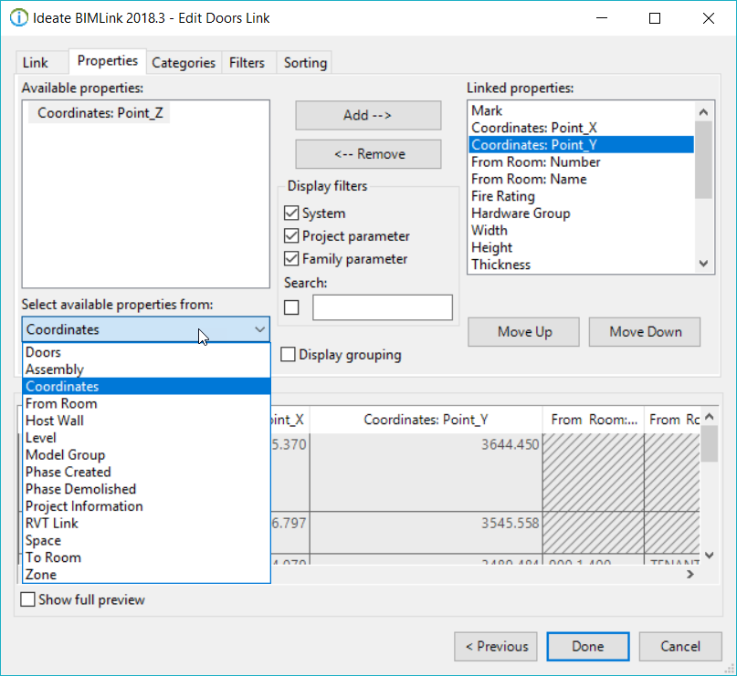
5. Export the Link in XLS (Excel 97-2003) format:  
   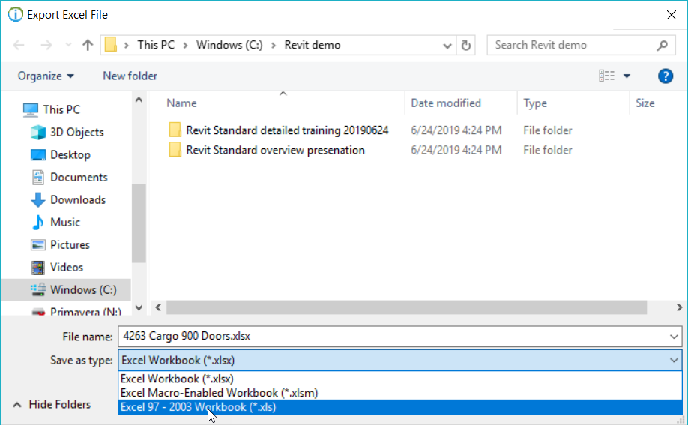

## Transfer package

1. Fill out the transmittal form.

1. Upload the files to SharePoint and notify the GIS team in email.

**BIT Team Member:**

Adam Rendek: Adam.rendck@flysfo.com

**GIS Team Member**

Guy Michael: Guy.Michael@flysfo.com